Chance-It

User Manual

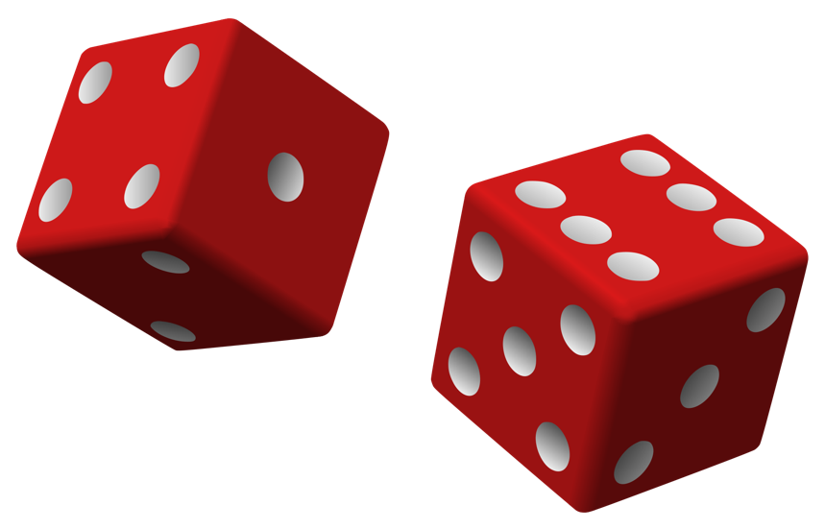Version 1.0

**CMMS Systems**

Chris Wong

Matthew Casiro

Melissa Page

Sheryll Tabamo

Table of Contents

Game Rules 3

Launching the Program 3

Opening the Game 3

Getting Started 4

Starting a Game 5

Local Play Mode 5

Network Play Mode 6

Playing a Game 7

Taking a Turn 7

In-Game Help Menu 7

Appendix A 8

# Game Rules

1. A game of Chance-It involves two players. The object of the game is to be the player with the highest score after completing 20 rounds of play.
2. During a round, each player takes a turn. A player’s total score is the sum of their turn scores. At the beginning of the game, each player rolls a die: high goes first.
3. At the beginning of their turn, a player rolls two six-sided dice and records the sum, called their first roll.
4. After their first roll, a player must decide whether to stop or continue (i.e., chance-it).
5. If a player decides to stop, then their turn ends and their score for that turn is the sum of all rolls during that turn; if the player decides to continue, they roll the dice again.
6. If in re-rolling the dice, a player re-rolls their first roll (any combination of dice that results in the same sum), then their turn ends and their score for that turn is zero; otherwise, go to step 5.

# Launching the Program

### Opening the Game

Chance-It is run through ‘terminal’ on a Linux operating system.

1. Open the terminal for your operating system
2. Navigate to the folder where the Chance-It executable is saved
3. Run the file with the command: ./ChanceIt

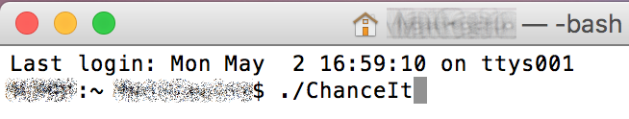

Figure –Application Launch from Terminal

### Getting Started

When the game loads, the rules will display. Ensure you are familiar with the rules before proceeding. Press enter to show the main menu.

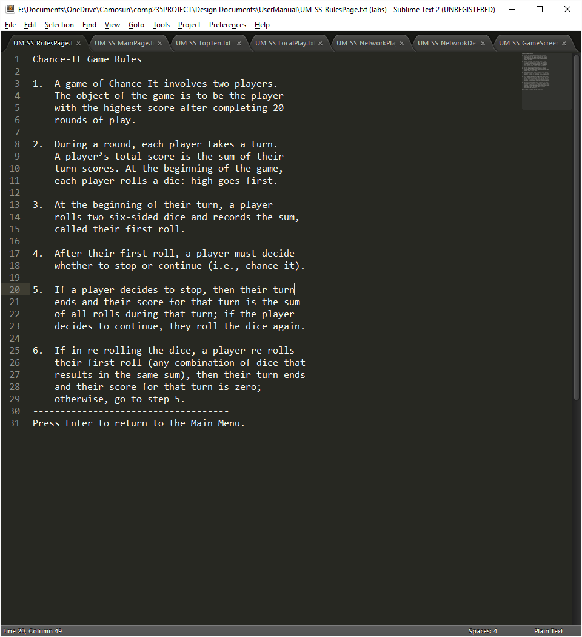

Figure –Rules Splash Page

Commands on the main menu include:

* **L** Local Play Mode Play locally against another player or an AI player
* **N** Network Play Mode Play manually or use an AI to compete online
* **V** View High Scores See the top ten highest local human scores
* **R** Rules Display the game rules
* **E** Exit Exit the game application

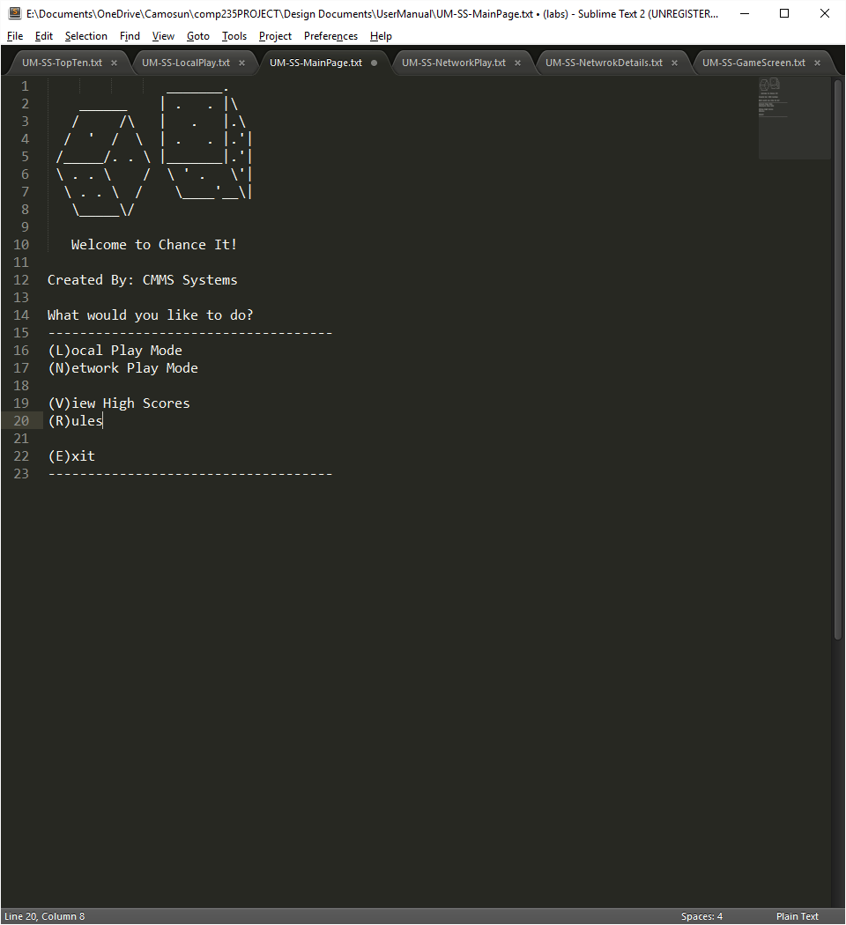

Figure –Main Menu

The **V** command will display the high score list:

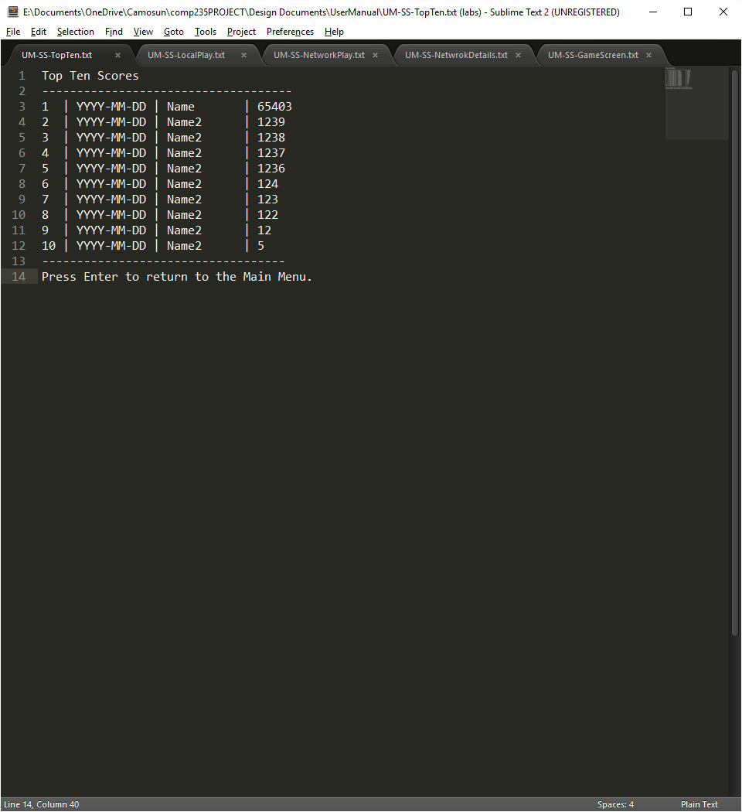

Figure –Top Ten Highest Scores List

# Starting a Game

### Local Play Mode

After selecting a local game, you will choose whether to play against another human opponent, or against a computer-controlled AI.

* **S** Single Player Play locally against a computer controlled AI
* **M** Multiplayer Play against another human opponent
* **P** Previous Menu Return to the previous game menu
* **E** Exit Exit the game application

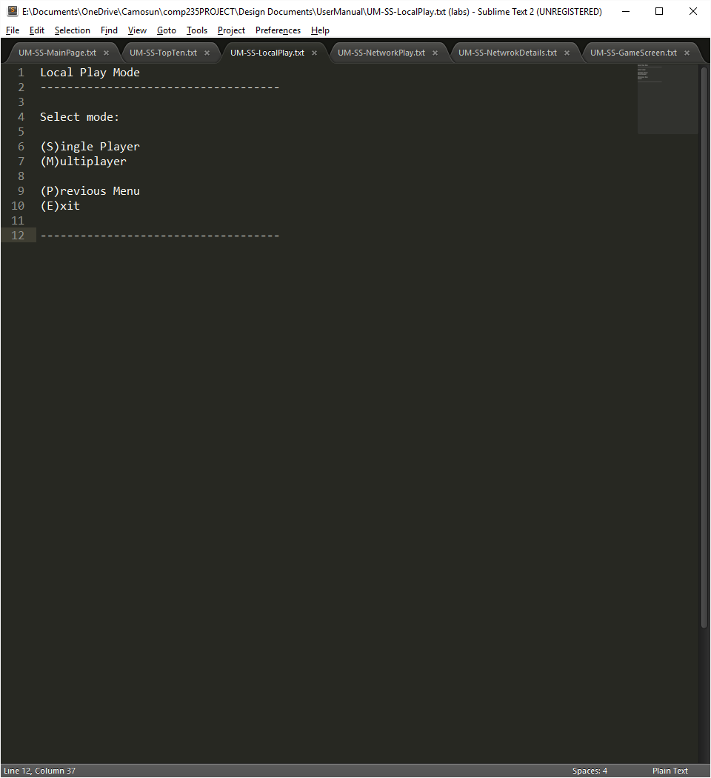

Figure –Local Play Menu

If you select Single Player, you will be prompted to enter your name, if you select Multiplayer, both players will be prompted to enter names. Once names are entered, the game will start.

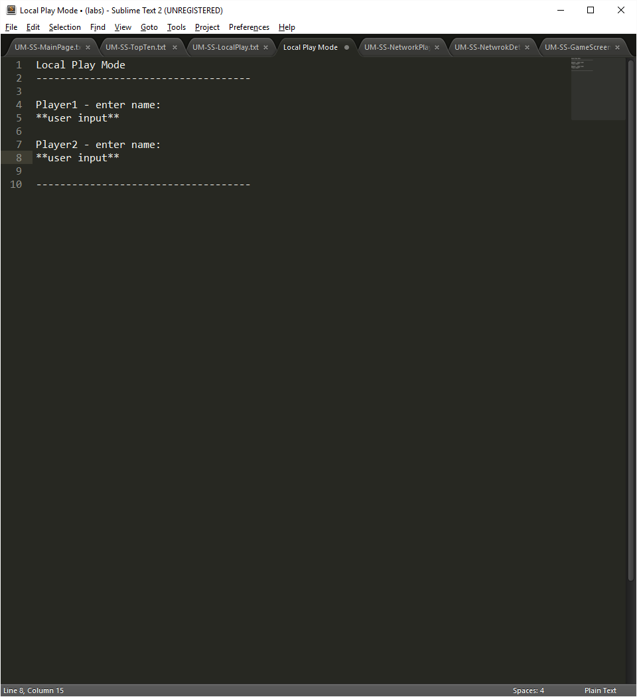

Figure –Player Name Input

### Network Play Mode

After selecting a network game, you will choose whether to play the game manually, or let a computer-controlled AI play on your behalf.

* **H** Human Player You will control the game decisions
* **C** Computer Player A computer will control the game decisions
* **P** Previous Menu Return to the previous game menu
* **E** Exit Exit the game application

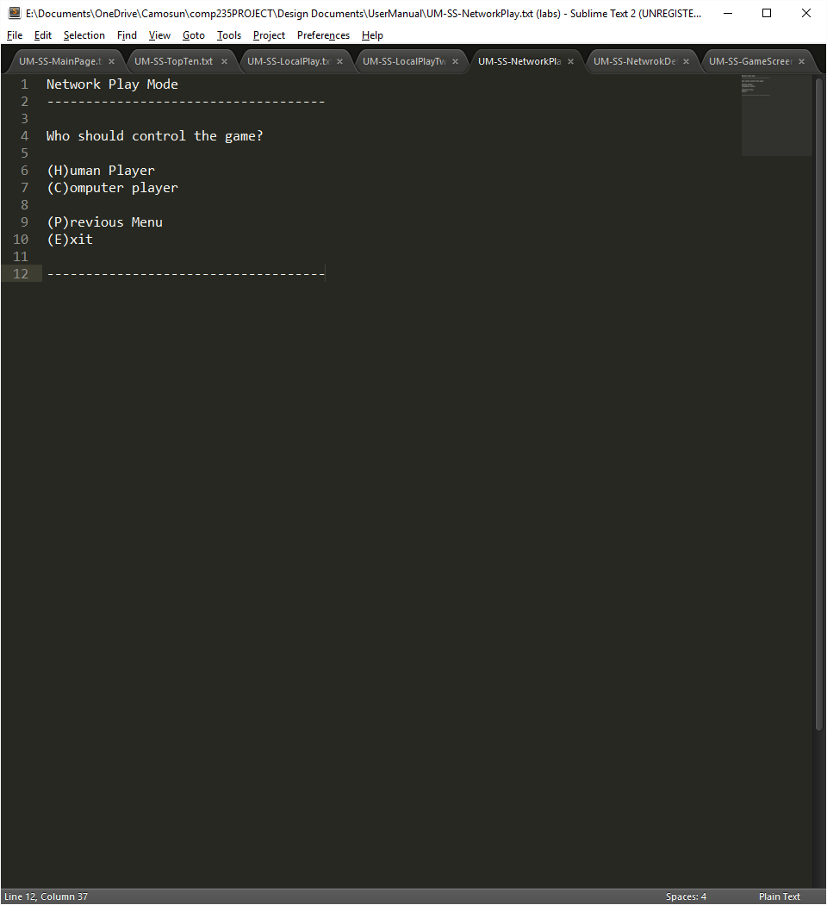

Figure –Network Play Menu

If you select Human Player, you will be prompted to enter your name. After entering your name (if required) you will be taken to the network connection screen.

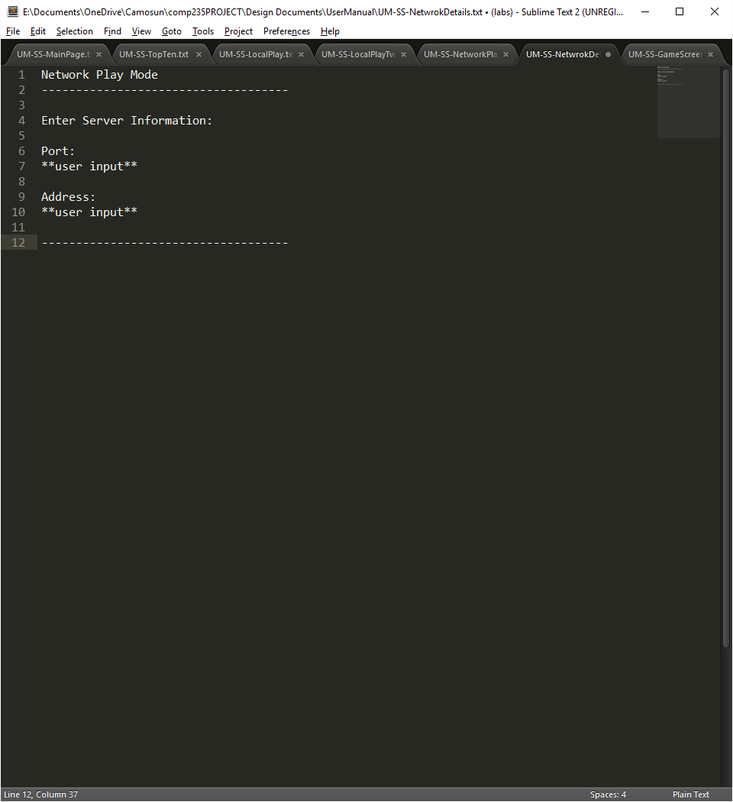

Figure –Network Connection Information

# Playing a Game

### Taking a Turn

When it is the player’s turn, the dice are rolled and the sum recorded as “First roll”. The player’s goal is to roll the dice as many times as possible (earning points based on the sum of the dice every time) without repeating the sum of the First roll. If you repeat the sum from the first roll then the turn ends and no points are recorded.

* **R** Roll Dice The dice are rolled and the numbers summed
* **S** Stop Current Turn Stops current turn and adds points earned to total
* **P** Probability Display the probability of re-rolling the first roll
* **H** Help Display a help menu in-game
* **F** Forfeit Forfeit current game and return to the main menu

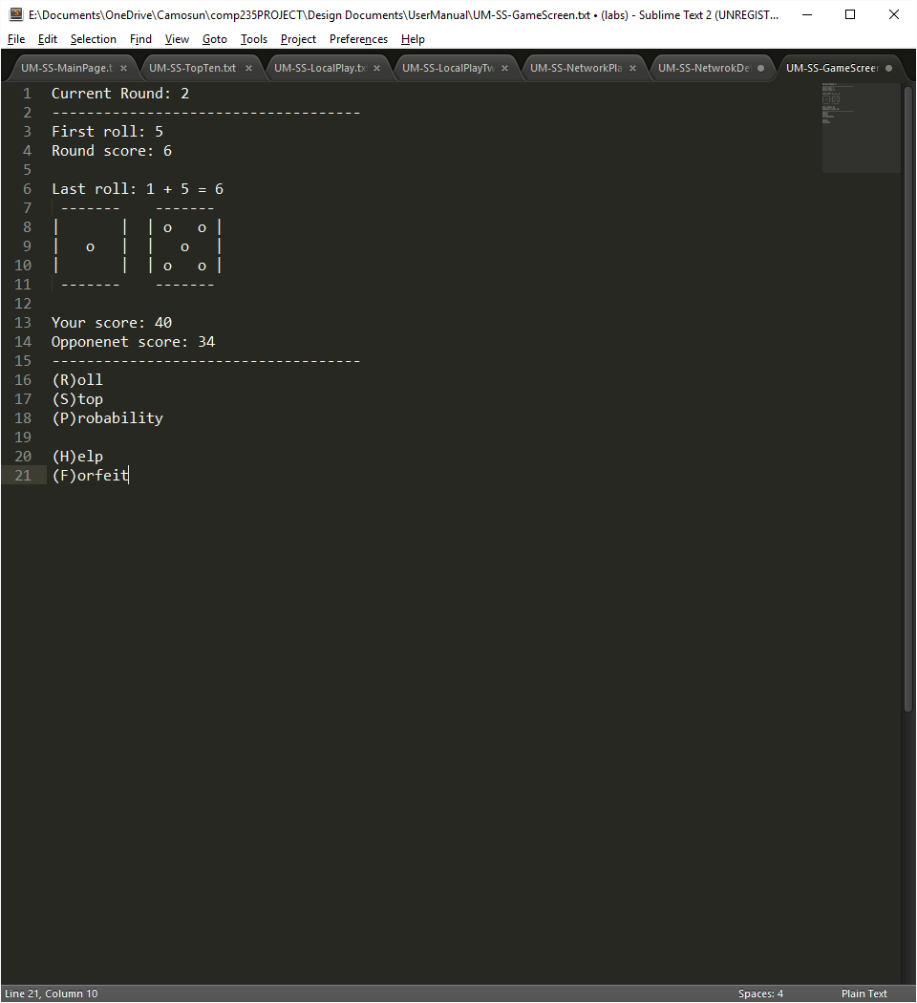

Figure –Active Game Screen

### In-Game Help Menu

The in-game help menu provides details on how to use the game commands.

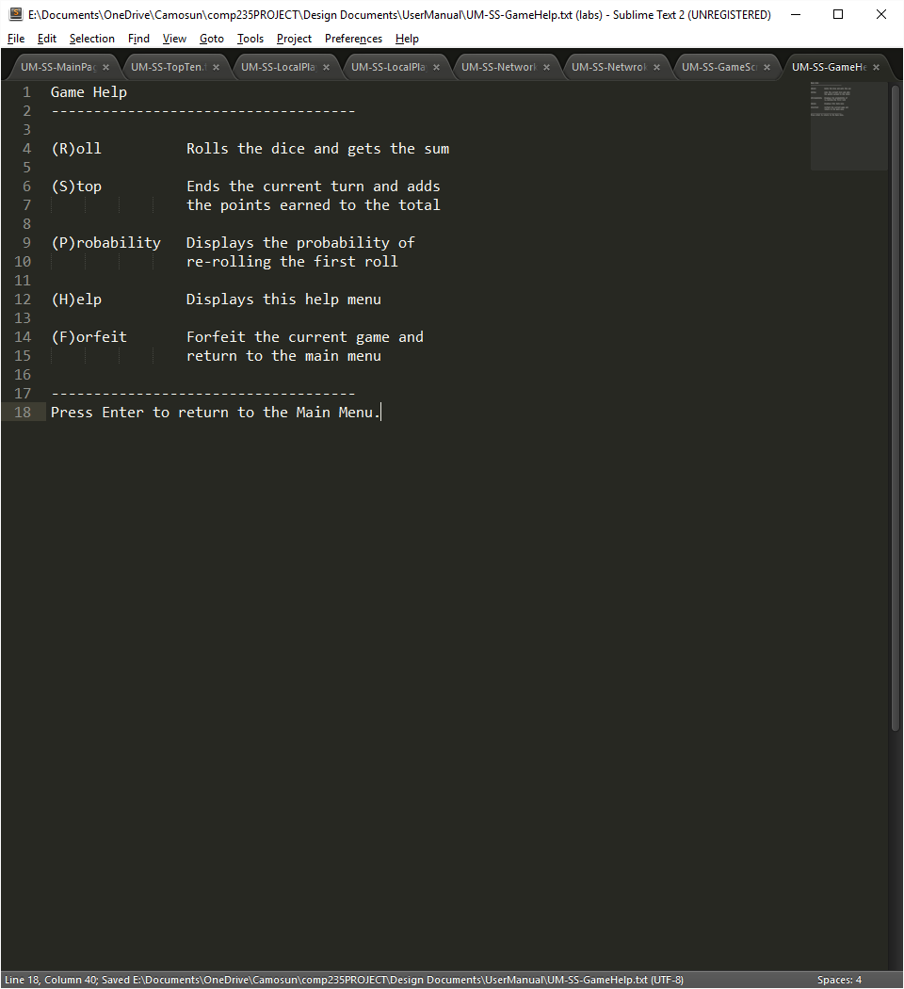

Figure –Active Game Help Menu

# Appendix A

Application Forward-Progression Flow Chart

